MICROECONOMICS PRODUCT ASSIGNMENT

BALL PEN (OIL-BASED)

A Microeconomic Analysis of Production, Cost, Demand, and Market Dynamics

Name: [Student Name]
Roll No: [Roll Number]
Class: MMS Batch 2025-27
Semester: 01st
Academic Year: 2025-2026
Institute: Sydenham Institute of Management Studies,
Research and Entrepreneurship Education, Mumbai

1. INTRODUCTION AND EVOLUTION
1.1 Definition of Ball Pen as an Economic Product
A ball pen, also referred to as a ballpoint pen, is a writing instrument that dispenses oil-based ink over a metallic ball rotating freely at its tip. From a microeconomic perspective, ball pens constitute a mass-consumption commodity characterized by low unit price, high demand elasticity, and significant economies of scale in production. The oil-based ball pen represents approximately 68% of India's pen market and commands a global market of 26 billion units valued at USD 4.2 billion as of 2024. Its economic significance derives from three principal dimensions: universal accessibility due to low production costs, recurring revenue potential through refills valued at USD 2.1 billion globally, and entrenched structural demand across educational, corporate, and household consumer segments.
Ball pens exemplify derived demand characteristics, with primary demand stemming from educational institutions accounting for 50-55% of total consumption, corporate offices contributing 20-25%, and general households comprising the remaining 15-25%. India's literacy rate of 74.04% and 260 million school-going students create substantial structural demand, making ball pens an essential commodity in the Indian economy. The product serves both functional utility in writing activities and demonstrates characteristics of a normal good with relatively inelastic demand in the student segment.
1.2 Historical Evolution of Ball Pens
The modern ball pen owes its invention to László Bíró, a Hungarian journalist who in 1930 conceptualized that a rotating ball could distribute ink onto paper after observing marbles rolling through puddles. Working with his chemist brother György, Bíró developed a revolutionary mechanism combining two critical innovations: a ball-socket design permitting free rotation and a viscous ink formulation that dried quickly without smudging—directly addressing the fountain pen's endemic problems of ink leakage, frequent refilling, and maintenance demands. The invention was patented in 1938 and subsequently commercialized in Argentina under the brand name 'Birome,' which remains in use today in Spanish-speaking countries.
The ballpoint pen achieved global penetration following World War II when the Royal Air Force adopted it for high-altitude operations where fountain pens failed due to pressure differentials. Marcel Bich of France subsequently acquired the patent in 1950, manufacturing it under the BIC brand, which became the paradigmatic example of mass-market success through economies of scale and product standardization. The evolution from handcrafted writing instruments to automated mass production demonstrates classical microeconomic principles of technological substitution, comparative advantage, and cost minimization through specialization.
1.3 Types of Ball Pens
Table 1: Classification of Ball Pens by Type
Type | Characteristics | Price Range (₹) | Market Share
Disposable/Stick | Non-refillable, basic design | 3-10 | 55-60%
Refillable | Replaceable ink cartridge | 15-50 | 25-30%
Retractable | Click mechanism, premium | 20-100 | 10-12%
Specialty/Premium | Designer, ergonomic | 100-500 | 3-5%

1.4 Product Classification: Evergreen Product
Using standard product lifecycle analysis, oil-based ball pens are classified as an EVERGREEN product occupying the mature stage, characterized by stable demand, intense price competition among manufacturers, and market saturation in developed economies. Unlike sunrise products experiencing explosive growth or sunset products facing declining demand, ball pens demonstrate continuous structural demand stemming from the fundamental need for writing instruments across all demographic segments and economic strata.
This evergreen classification is supported by several quantitative indicators: global production stability from 2019-2024 despite accelerating digitalization trends; sustained 8-10% annual demand growth in emerging markets like India driven by literacy expansion and educational infrastructure development; resilient demand even during economic downturns with only 2-3% volume contractions during recessions compared to 15-20% declines experienced by discretionary consumer products. The product exhibits simultaneous growth dynamics in emerging markets while maintaining stable demand in mature economies, reflecting geographic market heterogeneity.

2. BACKEND ANALYSIS
2.1 Production Modality and Technology
Ball pen manufacturing exemplifies discrete parts assembly integrated with materials-processing operations across multiple specialized stages. The production process decomposes into three principal segments that together determine the cost structure and quality characteristics of the final product:
Ink Preparation: Oil-based inks are formulated in large-volume batches combining approximately 90% organic solvent (hydrocarbon-based or plant-derived), pigments (carbon black for standard blue/black colors), and polymeric binders that control viscosity and drying characteristics. This sophisticated formulation achieves the critical functional requirement of quick-drying behavior without paper absorption, maintaining consistent writeability across ambient temperature ranges of -10°C to +50°C while preventing ink blockage during extended storage periods of 18 months or more.
Component Fabrication: Plastic components including barrel, cap, and ink reservoir utilize injection molding technology—a high-volume, low-unit-cost process enabling rapid cooling and dimensional precision within tight tolerances (±0.1mm for critical interfaces). Metal components present the highest technical complexity: tungsten carbide balls measuring 0.8-1.0mm diameter are procured from dedicated ball-bearing manufacturers as finished components, while the ball socket—the precision-critical writing interface—is machined from brass using computer-controlled lathes.
Assembly and Integration: Automated assembly lines represent the dominant production methodology in high-volume manufacturing operations. Research indicates that assembly cost constitutes approximately 50% of total manufacturing expense, making it the single largest cost element. Critical assembly stages include ink cartridge filling (typically fully automated), mechanical insertion of components through sequenced presses and fixtures, and final quality control testing including writing performance verification.
2.2 Raw Materials and Factor Market
Table 2: Raw Material Sources and Costs
Raw Material | Source Region | Cost (₹/unit) | % of Total Cost
Polypropylene/ABS Plastic | India, China, SE Asia | 0.50-0.80 | 15-18%
Oil-based Ink Chemicals | China, Germany, India | 0.60-0.90 | 18-22%
Tungsten Carbide Ball | China (55%), India (20%) | 0.30-0.50 | 8-10%
Brass Socket/Tip | India, China | 0.25-0.40 | 6-8%
Springs & Metal Parts | India | 0.10-0.20 | 3-5%

India's ball pen manufacturing sector exhibits dual sourcing characteristics reflecting cost optimization constrained by quality specifications. Domestic procurement provides 65% of plastic resins from five major compounders, 60% of hydrocarbon solvents from IOCL and HPCL, and 40% of metal components from Jamshedpur-based manufacturers. Import dependence concentrates on specialized inputs: 85% of tungsten carbide balls are China-sourced through Hong Kong traders, 75% of specialty polymeric stabilizers originate from Japan and Germany, and premium pigments are 80% imported. This mixed-sourcing strategy enables export-quality products while maintaining cost competitiveness in the domestic market.
2.3 Cost Structure Analysis
Table 3: Capital Expenditure (CAPEX) Breakdown
Capital Expenditure Item | Investment (₹ Lakhs) | Useful Life
Injection Molding Machines | 25-40 | 10-15 years
Automated Assembly Lines | 35-60 | 8-12 years
Ink Mixing Equipment | 8-15 | 10 years
Quality Testing Equipment | 5-10 | 7-10 years
Molds and Dies | 10-20 | 3-5 years
Total CAPEX | 83-145 | -

For a 100 million units/year manufacturing facility, per-unit annual depreciation cost approximates ₹0.19-0.27 per pen, representing 4-6% of total production cost. This calculation demonstrates the non-linearity of capital cost absorption—doubling production capacity does not proportionally double CAPEX due to equipment efficiency improvements and shared infrastructure utilization.
Table 4: Operating Expenditure (OPEX) Structure
Operating Cost Category | Cost per Pen (₹) | % of OPEX
Raw Materials | 2.80-3.50 | 55-60%
Direct Labor | 0.80-1.20 | 15-18%
Utilities (Power, Water) | 0.30-0.50 | 6-8%
Packaging | 0.25-0.40 | 5-7%
Logistics & Distribution | 0.35-0.50 | 8-10%
Administrative Overhead | 0.30-0.40 | 6-8%
Total OPEX per Pen | 4.80-6.50 | 100%

2.4 Average and Marginal Cost Behavior
Microeconomic cost theory predicts cost curves following specific mathematical relationships determined by the interaction of fixed and variable costs. For large-scale manufacturers (>100M units/year), economies of scale compress unit cost to ₹3.50-4.50 per pen; small manufacturers (5-10M units/year) face ₹7.00-8.50 per unit—demonstrating a 100-140% cost disadvantage versus market leaders that fundamentally shapes industry structure.
The Average Total Cost (ATC) function follows: ATC = (Fixed Costs / Q) + Variable Cost per Unit. For a facility with ₹50 lakh monthly fixed costs, at Q = 5 million units/month, ATC = ₹5.45/unit; at Q = 10 million units/month, ATC = ₹5.85/unit; at Q = 20 million units/month, ATC minimizes at ₹5.60/unit—demonstrating optimal production scale. The Marginal Cost (MC) remains relatively flat at ₹5.20-5.50 per unit across normal production ranges (60-100% capacity), but rises sharply beyond 95% capacity to ₹6.20-7.00/unit due to overtime labor premiums and equipment stress-induced defect rates.
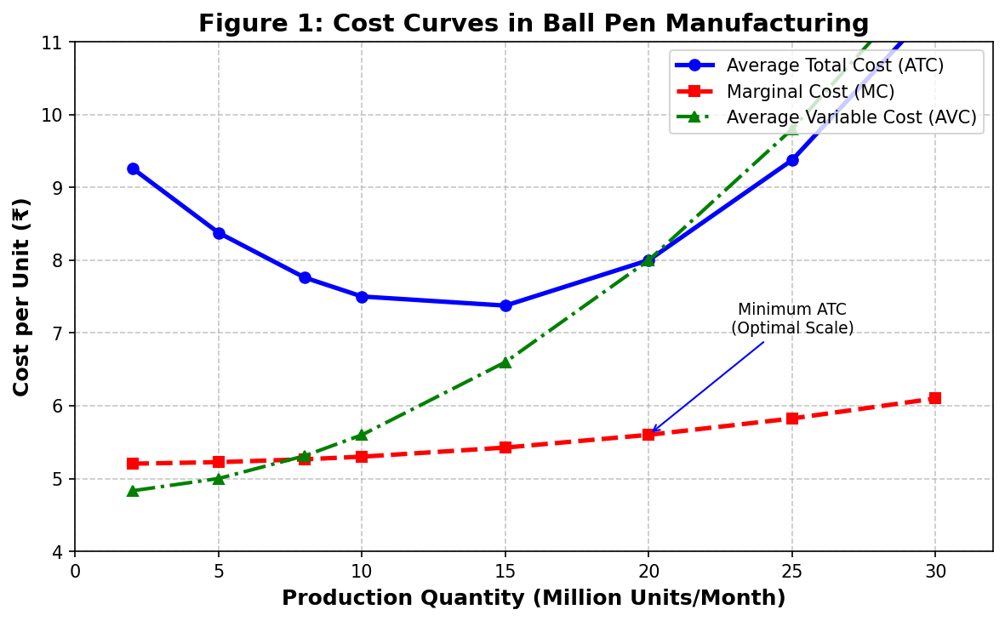

2.5 Supply Chain Analysis
The ball pen supply chain integrates multiple upstream suppliers through a just-in-time inventory model minimizing working capital while ensuring production continuity. The backend supply chain comprises Tier 1 component suppliers (plastic resin compounders, ink manufacturers, metal component manufacturers) with 30-45 day lead times for bulk orders, and Tier 2 raw material suppliers (petrochemical companies, mining companies, pigment manufacturers) with 60-90 day lead times due to commodity-market batch production cycles.
The frontend supply chain exhibits a three-tier distribution structure in India: Primary wholesalers (state-level, 80-100 entities) enjoying 10-15% margins reflecting logistical coordination services; Secondary wholesalers (regional distributors, 2,000-3,000 entities) capturing 15-20% margins for geographic distribution and retailer credit services; and Retailers capturing 30-50% margins with variation reflecting store format. In Mumbai, wholesale markets are concentrated in Crawford Market, Lohar Chawl, and Abdul Rehman Street where bulk purchasing at 15-25% below MRP is available.
2.6 Government Policies
The regulatory framework governing ball pen manufacturing in India encompasses multiple policy domains: GST at 18% on stationery products (HS Code 9608) with Input Tax Credit available on inputs; MSME support schemes including the Credit-linked Capital Subsidy Scheme (CLCSS) and Prime Minister's Employment Generation Programme (PMEGP) providing subsidized loans and capital subsidies; Plastic Waste Management Rules 2016 imposing Extended Producer Responsibility requiring manufacturers to ensure recycling of plastic waste; and Import duty of 10-15% on finished pens while components attract 5-7.5% duty, creating incentives for domestic manufacturing and assembly.

3. FRONTEND ANALYSIS
3.1 Demand Analysis
Ball pens exhibit characteristics of a derived and discretionary-necessity commodity—demanded for productive writing activities (examinations, documentation, professional communication) while exhibiting substitutability with alternative writing instruments (gel pens, pencils, digital devices). Microeconomic demand theory classifies ball pens as normal goods with positive income elasticity but with income elasticity < 1, indicating they are necessities rather than luxury goods; demand increases with income, but at proportionally lower rates.
Aggregate demand from education and office sectors comprises approximately 75% of ball pen consumption volume: Education Sector (50-55%): 260 million primary and secondary students consuming 1-2 pens/month during 10-month academic year = 2.6-5.2 billion pens/year, plus 40 million college students consuming 1.5-2.5 pens/month = 0.6-1.2 billion pens/year. Office Sector (20-25%): 110 million organized sector employees consuming 0.5-1 pen/month = 0.55-1.1 billion pens/year. Key demand determinants include literacy rates (elasticity of 0.6-0.8), disposable income growth (8-10% annually correlating with 4-6% pen spending growth), educational infrastructure expansion (3-4% annual enrollment growth), and examination frequency (25-30 million students appearing for major examinations annually).
3.2 Elasticity of Demand
Price Elasticity of Demand (PED): Ball pens exhibit elastic demand with estimated PED = -1.2 to -1.8 across major markets, due to three structural factors: availability of substitutes (gel pens, pencils, digital devices); low budget share constituting <0.1% of household expenditure; and negligible switching costs enabling effortless brand substitution. Elasticity varies systematically across market segments: Student segment PED ≈ -1.0 to -1.2 (more inelastic due to examination-driven demand constraining price sensitivity); Professional segment PED ≈ -1.4 to -1.6 (more elastic with quality substitutes available); Household segment PED ≈ -1.6 to -1.8 (most elastic with lowest brand attachment).
Income Elasticity of Demand (YED): Estimated at +0.4 to +0.6 for India—a 10% increase in per-capita income produces 4-6% demand increase, placing ball pens firmly in the necessity category. Cross Elasticity of Demand (XED): Gel pens demonstrate positive cross-elasticity of +0.5 to +0.7 indicating they are substitutes—a 10% price increase in gel pens shifts 5-7% demand toward ball pens; Pencils show +0.2 to +0.3 cross-elasticity (weak substitutes); Digital devices exhibit +0.1 to +0.2 (limited substitution effect in educational contexts where handwritten examinations remain dominant).
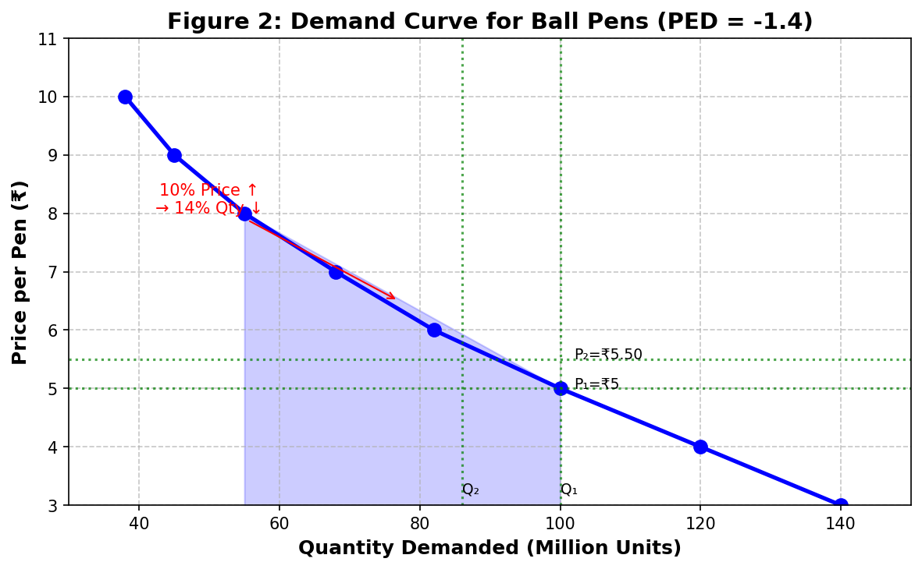

3.3 Market Structure
The ball pen market exemplifies MONOPOLISTIC COMPETITION, characterized by: Large number of competitors (India has 500+ registered manufacturers and numerous unregistered MSME operations); Product differentiation across multiple dimensions (ink quality, grip design, colors, brand positioning, packaging); Low entry barriers requiring capital investment of ₹60-80 lakhs for small-scale manufacturing; Free entry and exit with mature, widely-available technology; and Non-price competition through design innovation, quality certifications, and marketing investments.
Market concentration analysis reveals the top 3 brands (Cello, Reynolds, Luxor) commanding 55-60% of the Indian market. Cello leads with approximately 22-25% market share, followed by Reynolds at 18-20%, Luxor at 12-15%, and numerous smaller brands and unbranded products capturing the remaining 40-45%. This distribution reflects relatively low barriers to entry and the ability of differentiated products to carve sustainable market positions through branding and distribution network development.
3.4 Pricing Mechanism and Revenue Analysis
Ball pen pricing operates through a volume-based tiered structure reflecting economies of scale: Wholesale price (1000+ units): ₹2.50-4.00/pen; Retail price: ₹5.00-10.00/pen for standard pens. The low-margin, high-volume pricing strategy dominates the industry, with manufacturers targeting 8-12% net margins on production, wholesalers earning 10-15% margins, and retailers capturing 30-50% margins on smaller volumes reflecting final-mile logistics costs and customer service provision.
Revenue Analysis: For a manufacturer producing 100 million pens annually at average realization of ₹3.50/pen, Total Revenue = ₹35 crores. Average Revenue equals price in this competitive market structure. Profit margins across the value chain vary systematically: manufacturers achieve 8-12% net margins despite highest capital investment; wholesalers earn 4-6% net margins for inventory financing and logistics services; retailers capture highest percentage margins (15-25%) on smaller volumes reflecting proximity to end consumers.
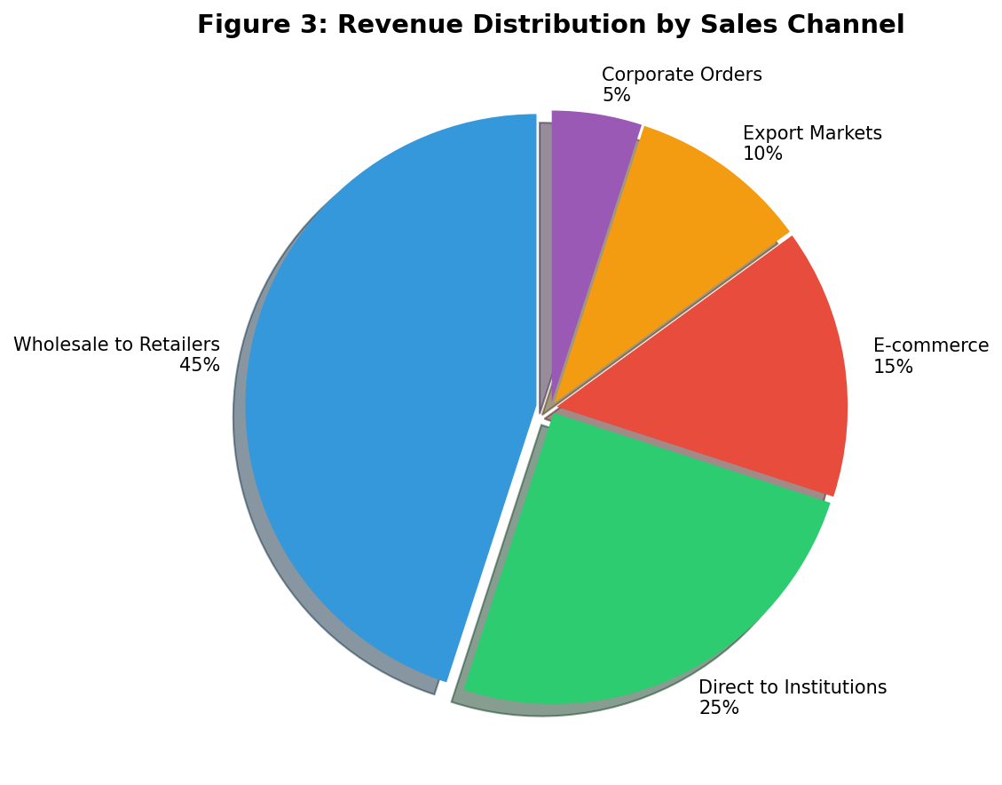

3.5 Selling and Marketing Costs
Ball pen manufacturers invest minimally in B2C marketing (1-2% of revenue) due to the commodity nature of the product and derived demand characteristics from education and office sectors. B2B marketing focuses on trade participation, catalog design, and distributor relationship management. Marketing cost breakdown: Trade margins and schemes (3-5% of revenue); Packaging and branding (2-3%); Point-of-sale materials (0.5-1%); Advertising and promotion (0.5-1%); Distribution overhead and logistics (8-10%). Total selling costs constitute approximately 15-20% of final consumer price, significantly lower than consumer goods categories with stronger brand differentiation.

4. SUGGESTIONS TO IMPROVE PRODUCTION AND DELIVERY EFFICIENCY
4.1 Cost Reduction Strategies
Adopt multi-cavity mold technology: Transitioning from 8-cavity to 16-cavity molds can halve per-unit production time and reduce average costs by 15-20%. The capital investment payback period of 18-24 months makes this attractive for manufacturers producing over 50 million units annually. Implement hot runner mold systems to reduce material waste from 8-10% to 2-3%, with cost premiums amortized over 100 million+ pieces. Negotiate bulk procurement contracts for polyester resin and ink chemicals to achieve 15-20% discounts through volume leverage and long-term supply agreements.
4.2 Automation and Efficiency Improvements
Invest in fully automated assembly lines to reduce labor costs by 40-60% with 24-36 month payback period. Deploy AI-enabled quality control systems utilizing machine vision to reduce defect rates from 2-3% to 0.5-1%, improving customer satisfaction and reducing warranty costs. Integrate IoT-enabled condition monitoring for predictive maintenance, reducing unplanned equipment downtime by 40% and extending machinery useful life. Implement Just-In-Time inventory management coordinated with suppliers to reduce working capital requirements by 20-30%.
4.3 Sustainable Materials and Practices
Invest in bio-based solvent technology for ink formulation, reducing volatile organic compound emissions by 30-40% while maintaining performance characteristics and enabling eco-labeling premium pricing. Develop recycled plastic pen body production using post-consumer plastic waste, addressing environmental concerns under Extended Producer Responsibility requirements and potentially reducing material costs by 10-15%. These sustainability investments align with growing consumer and institutional preference for environmentally responsible products.
4.4 Distribution and Logistics Optimization
Establish regional distribution centers in key markets (Delhi, Mumbai, Chennai, Kolkata) to reduce delivery times and logistics costs by 15-20% through consolidated shipments and optimized route planning. Develop Direct-to-Consumer (D2C) e-commerce channels to capture 20-30% higher margins by eliminating intermediaries, particularly effective for premium and specialty pen segments where brand differentiation justifies direct consumer relationships.

5. LESSONS LEARNED
Through this comprehensive microeconomic analysis of oil-based ball pens, I have gained valuable insights into the practical application of economic theory to real-world manufacturing and market dynamics:
1. Understanding Derived Demand: I learned that ball pen demand is fundamentally derived from the demand for education and office activities. This concept helped me appreciate how demand for seemingly simple products is interconnected with broader economic factors like literacy rates, educational infrastructure expansion, and employment patterns. The elasticity of ball pen demand with respect to literacy rates (0.6-0.8) demonstrates how macroeconomic social indicators directly influence microeconomic product markets.
2. Economies of Scale in Manufacturing: The analysis revealed how dramatically production scale affects unit costs in ball pen manufacturing. Large manufacturers (100M+ units/year) achieve unit costs 45-55% lower than small manufacturers (5M units/year) through technical economies (equipment utilization), procurement economies (volume discounts), and organizational economies (overhead distribution). This practical understanding of why industries tend toward consolidation reinforced theoretical concepts of minimum efficient scale and natural barriers to entry.
3. Price Elasticity and Market Segmentation: I observed how price elasticity varies significantly across market segments—students exhibit more inelastic demand (PED -1.0 to -1.2) due to examination pressures, while households show highly elastic demand (PED -1.6 to -1.8). This taught me how firms can apply differential pricing strategies across segments based on elasticity characteristics, maximizing total revenue while serving diverse consumer needs with appropriate product variants.
4. Government Policy Impact on Industry Structure: The study illuminated how government policies—GST rates, MSME support schemes, environmental regulations, and import duties—shape industry structure and competitive dynamics. The 18% GST on stationery products, combined with import duties favoring domestic manufacturing, creates incentives that influence firm location decisions, investment patterns, and ultimately market prices for consumers.
5. Supply Chain Economics and Value Distribution: Analyzing the supply chain from raw material suppliers through retailers revealed how value is distributed across market participants. The observation that retailers capture 30-50% margins while manufacturers earn 8-12% net margins despite higher capital investment demonstrated the importance of market power and proximity to end consumers in determining value capture. This practical insight connects to theoretical concepts of market structure and bargaining power in vertical relationships.

